CAD design of a corporate building:

A) Layout

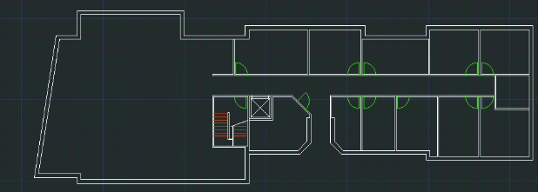

B) Layout with coordinate points with starting point (0,0)

